Hijjawi faculty for Engineering Technology
Department of Computer Engineering

“PC-based oscilloscope and oscillator”

Supervised By:
Dr. Adnan Al-Nasan

Team members:
Yahia Mohammad Al-Hami
Mohammed Khair Ali Shatnawi
Ayman Habeb Jebrel

June, 2008
Table of Contents
- Chapter One: OCSILLOSCOPE AND FREQUENCY GENERATOR------ | 8
- Introduction--------------------------------------------------------------------------------- | 8
- Oscilloscope and frequency generator--------------------------------------------- | 9
- Oscilloscope----------------------------------------------------------------------- | 9
- Frequency Generator----------------------------------------------------------- | 10
1.3 Commercial cost analysis---------------------------------------------------------------- | 11
1.4 Project goals-------------------------------------------------------------------------------- | 11
1.5 Thesis organization------------------------------------------------------------------------ | 12
- Summary------------------------------------------------------------------------------------- | 12
- Chapter Two: PROJECTS DESIGNS------------------------------------- | 13
2.1 Overview------------------------------------------------------------------------------------ | 13
2.2 Suggested design-------------------------------------------------------------------------- | 14
2.2.1 USB design---------------------------------------------------------------------- | 14
2.2.1.1 Design A------------------------------------------------------------- | 14
2.2.1.2 Design B------------------------------------------------------------- | 18
2.2.2 Pure Electronic design---------------------------------------------------- | 18
2.2.2.1 XR-2206 Signal generator-------------------------------------- | 19
2.2.2.2 USB cable----------------------------------------------------------- | 19
2.2.3 Sound Card-------------------------------------------------------------------- | 20
2.2.3.1 DC component------------------------------------------------------ | 21
2.3 Suggested design comparisons------------------------------------------------------ | 23
- Summary--------------------------------------------------------------------------------- | 23
- Chapter Three: PIC MICROCONTROLLER------------------------------------ | 24
3.1 What is a microcontroller-------------------------------------------------------------- | 24
3.2 Why to Use a Microcontroller-------------------------------------------------------- | 25
3.2.1 Power Supply------------------------------------------------------------------- | 26
- Reset button and Oscillator---------------------------------------------- | 26
3.3 Circuit Layout and Construction------------------------------------------------------ | 27
3.4 Developing a Project Using PIC MCU------------------------------------------------ | 28
3.5 PIC16F877A Microcontroller--------------------------------------------------------- | 28
3.6 Construction of PIC Programs--------------------------------------------------------- | 29
- Microcontroller Main Functions----------------------------------------------------- | 30
- Summary----------------------------------------------------------------------------------- | 30
- Chapter Four: HARDWARE DESIGN------------------------------------------- | 31
4.1 Hardware components specifications---------------------------------------------- | 31
4.1.1 16F877A PIC microcontroller--------------------------------------------- | 31
4.1.2 Crystal frequency and its configuration-------------------------------- | 32
4.1.3 Power supply------------------------------------------------------------------ | 32
4.1.4 Other components----------------------------------------------------------- | 33
4.2 Digital-to-Analog Converter (DAC) construction--------------------------------- | 34
4.3 Parallel port interfacing------------------------------------------------------------------ | 36
4.3.1 What is a parallel port? ----------------------------------------------------- | 36
4.3.2 Parallel port Registers and BIOS mode---------------------------------- | 36
- More analysis--------------------------------------------------------------- | 38
4.4 Overall hardware circuitry-------------------------------------------------------------- | 38
- Summary ------------------------------------------------------------------------------ | 39
- Chapter Five: SOFTWARE DESIGN--------------------------------------------- | 40
- Required Software----------------------------------------------------------------------- | 40
5.2 Software programming tools---------------------------------------------------------- | 41
5.3 Basic software model--------------------------------------------------------------------- | 42
5.4 Step-by-step software scenario-------------------------------------------------------- | 42
5.4.1 Oscilloscope and synchronization problem----------------------------- | 44
5.4.2 Oscillator and synchronization problem-------------------------------- | 45
5.5 PC and PIC synchronization----------------------------------------------------------- | 46
5.6 Mathematics equations --------------------------------------------------------------- | 48
5.7 GUI applications-------------------------------------------------------------------------- | 49
5.7.1 Installing the GUI application---------------------------------------------- | 49
- Using the application------------------------------------------------------ | 49
- Oscillator window------------------------------------------------ | 50
5.7.2.2 Oscilloscope-------------------------------------------------------- | 52
5.7.2.3 Some important comments------------------------------------ | 53
5.8 Conclusion---------------------------------------------------------------------------------- | 53
5.9 Future Work------------------------------------------------------------------------------- | 53
5.10 Summary---------------------------------------------------------------------------------- | 53

List of Figures

Page | Description | Figure
9 | Oscilloscopes | 1.1
10 | Frequency Generator | 1.2
16 | Pin diagram for 16C745 | 2.1
16 | Circuit diagram | 2.2
17 | USB Lines | 2.3
19 | XR-2206 pin diagram | 2.4
21 | Original sine signal | 2.5
21 | Sine signal without DC-component | 2.6
22 | Sound card cross view | 2.7a
22 | Sound card top view | 2.7b
24 | PIC 16F877A Microcontroller | 3.1
25 | PIC16F877A Pin-out | 3.2
26 | 7805 5V regulator | 3.3
27 | RESET connections | 3.4a
27 | Oscillator connections | 3.4b
31 | 16F877A pin-out connections | 4.1
33 | Power supply adapter | 4.2
34 | Resistor network DAC converter | 4.3
35 | Digital input / analog output relation | 4.4
36 | Parallel port cable | 4.5
39 | Overall circuit | 4.6
42 | Basic software model | 5.1
43 | Software flowchart | 5.2
47 | General synchronization sequence diagram | 5.3
50 | Oscillator window | 5.4
51 | A generated square waves in oscillator window | 5.5
52 | Sine wave (2.4KHZ, 5 volt) | 5.6a
52 | Sawtooth wave (4 KHz, 2.5 volt) | 5.6b
52 | Oscilloscope window | 5.7

List of Tables

Page | Description | Figure
14 | Hardware components | 2.1
15 | Design software | 2.2
18 | Electronic Components | 2.3
23 | Designs comparisons | 2.4
29 | Key Features of Different Microcontrollers | 3.1
32 | PIC16F877A functions | 4.1
35 | Digital input and analog output relation | 4.2
36 | Parallel port registers | 4.3
37 | Parallel port pin’s uses | 4.4
41 | Software programming tools | 5.1
51 | Different signal types specifications | 5.2

Abstract

Electronic engineering devices play a significant rule in engineering studies in universities and colleges. The nature of engineering studies requires a practical work to fully understand the scientific theories. But because of the high cost of engineering devices, it is still very difficult for engineering students to buy it.
We developed a new device that is based on nature and functions of oscilloscopes and oscillators, in order to produce a small, lightweight and inexpensive device that can be used and owned by all engineering students.
In general, the results obtained proved the expectations of applying and developing such robust and reliable devices in engineering studies.
CHAPTER 1
OCSILLOSCOPE AND FREQUENCY GENERATOR
In this chapter, fundamental concepts of oscilloscope and frequency generator are presented to provide the reader with the fundamental knowledge necessary to understand the thesis.
Then it is followed by an overview of oscilloscope and frequency generator, their characteristics, major applications, and their usage in engineering laboratories.
Then we discuss challenges in the area of oscilloscope and frequency generator followed by their commercial costs. Finally, we state the project goal and the organization of the thesis.

  - Introduction

Engineering labs play a significant rule in learning; recent studies prove that practical studies have lots of benefits compared with the theoretical studies for science students.
Engineering labs help students to implement and test scientific theories and allow them to develop their own creative ideas, apply scientific experiments and let them think and see how they will be able to apply theories in order to enhance and change community to the better by developing and inventing new technologies.
Most of engineering labs specially the electrical, electronic and communication ones are equipped with different devices such as: Oscilloscope, frequency generator and power supply. Those devices are important for engineering students to apply, debug and test scientific experiments.
For example, when a student wants to build an AC voltage amplifier electric circuit, the input is an AC signal waveform (Rectangle, Triangle, or Sinusoid) and the output is an amplified AC signal with a certain gain. The student should test the circuit with different signals to see that the output is varying according to the Input or not. This is absolutely done by oscilloscope and oscillator. However he/she will not build the circuit at home but they will build it at laboratories because they are equipped with the necessary devices.
Most of engineering students around the world wish to have their own engineering devices, especially the oscilloscope and frequency generator. But it is too expensive!
  - Oscilloscope and frequency generator
1.2.1 Oscilloscope
An oscilloscope (sometimes abbreviated CRO, for cathode-ray oscilloscope, or commonly just scope or O-scope) is a type of electronic test equipment that allows signal voltages to be viewed, usually as a two-dimensional graph of one or more electrical potential differences (vertical axis) plotted as a function of time or of some other voltage (horizontal axis).
A typical oscilloscope is a box with a display screen, numerous input connectors, and control knobs and buttons on the front panel. To enhance measurement, a grid called graticule is drawn on the screen. Each square in the graticule is known as a division.
The signal is fed to one of the input connectors, which is usually a coaxial connector such as a BNC or N type. If the signal source has its own coaxial connector, then a simple coaxial cable is used. Otherwise, a special cable called 'scope probe', supplied with the oscilloscope, is used.
General-purpose oscilloscopes have a standardized input resistance of 1 mega ohm in parallel with a capacitance of around 20 Pico farads. This allows using of standard oscilloscope probes. Scopes used with very high frequencies may have 50-ohm inputs, which should be connected directly to a 50-ohm signal source or used with Z0 or active probes. It is used to measure voltage.
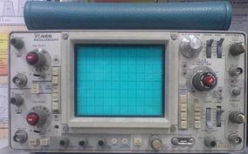
Oscilloscope has different frequent uses, it can be used for troubleshooting malfunctioning electronic equipment, graphically showing signal, checking newly designed circuits and it helps software engineers who program electronic components like Programmable IC (PIC). Figure 1.1 shows a general oscilloscope device.
Figure 1.1 Oscilloscopes
1.2.2 Frequency Generator
A frequency generator is a device produces simple repetitive waveforms. Such devices contain an electronic oscillator; a circuit that is capable to create a repetitive waveform. (Modern devices may use digital signal processing to synthesize waveforms, followed by a digital to analog converter, or DAC, to produce an analog output).
The most common waveform is a sine wave, but sawtooth, step (pulse), square, and triangular waveform oscillators are commonly available as they are arbitrary waveform generators (AWGs). If the oscillator operates higher than the audio frequency range (>20 kHz), the generator will often include some sort of modulation function such as amplitude modulation (AM), frequency modulation (FM), or phase modulation (PM) as well as a second oscillator that provides an audio frequency modulation waveform.
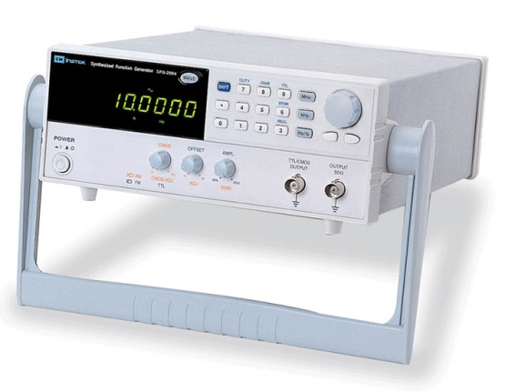
Function generators are typically used in simple electronics repair and design; they are used to stimulate a circuit under test. A device such as an oscilloscope is used to measure the circuit's output. Function generators vary in the number of outputs they feature, frequency range, frequency accuracy, stability, and several other parameters. Figure 1.2 shows a general frequency generator device
Figure 1.2 Frequency Generator.

  - Commercial cost analysis

To have an oscilloscope or a frequency generator at home is still a dream for most of engineering students since it is expensive, not only for students but also for engineering or science laboratories. We know that all engineering colleges are responsible for establishing scientific laboratories equipped with all electronic devices needed to keep students updated with latest technologies and make them enabled to apply most of engineering theories, but because of the high cost, it is still difficult to establish such laboratories with tens of thousands of dollars.
So, Building a cheap oscilloscope or frequency generator will help in learning process and enable engineering students to build and develop their own projects and experiments and apply their creative ideas to enhance their skills in electronic circuits.

  - Project goals

The motivation of this project is to build a PC-Based oscilloscope and frequency generator with low cost components to provide engineering students the chance to build, simulate and test circuits, and measure all electronic circuits easily in an efficient way using only simple computer software and inexpensive and simple circuit.
Most of existing oscilloscopes or frequency generators provide best performance and do good job in engineering laboratories but with expensive cost. So, building such low-cost devices compared with the other commercial tools and designing independent software will be capable to solve a lot of problems specially the cost issue and will overcome the following limitations:
- Reduce the cost of basic equipment for electrical engineering labs.
- Help students to practice their scientific research and solve their problems and home works.
- Help universities create new labs and move quality of learning process forward by computerizing most of engineering labs.
- Reduce the physical size of function generator and oscilloscope by making it portable and easy to carry.

The goal of building a PC-Based project is to produce an efficient, small size, portable, cheap and easy to use function generator and oscilloscope and develop simple software that can be used and easily understood by engineers, students and other interested people.

  - Thesis organization

This thesis is organized as follows: chapter 2 will present Project design. It presents all suggested projects design and describes all advantages and disadvantages for both hardware and software. Chapter 3 presents and discusses the PIC microcontrollers and explains the advantages of using some PIC. Chapter 4 presents a description of hardware design and other related topics. Chapter 5 presents a software analysis and describes all programming tools and software needed to develop a stable application. The conclusion and future work suggestions are presented at the end of chapter 5.

  - Summary

In this chapter, an overview of oscilloscope and frequency generator was given and the basic characteristics were presented. We described several applications and uses of oscilloscope and frequency generator. Then we introduced a simple commercial cost analysis. Finally the goal of this project and the thesis organization were presented at the end of this chapter.
CHAPTER 2
PROJECTS DESIGNS

This chapter presents an overview of projects designs in section 2.1. In section 2.2 we discuss all suggested designs in details, in addition to their advantages and disadvantages. Brief comparisons of suggested design are tabled in section 2.3. Finally, we summarize this chapter in section 2.4.

2.1 Overview
During our research we tried to implement our project idea by more than one way, we kept on searching until we found excellent, cheap, simple and robust design. It’s not that easy to implement and get such a design but it’s necessary to choose the best one upon other suggested designs. However, a good design should consider the following points:
Cost: The main factor that affects any commercial project is its cost. Project’s cost is very important to be considered as the main limitation in all projects. For example, if a customer wants to buy a notebook, he/she always searches for latest technology, high speed and surely inexpensive one.
Weight and Size: This is very important problem for commercial oscilloscope and function Generator; traditional equipment is very heavy, large and not portable at all.
Functionality: Many designs have common features, advantages and disadvantages. But good design is to have advantages more than disadvantages. One of the most important points when preparing for a design is to get all functions needed for what the design is proposed. Then this design will be extremely succeeded.
Complexity: A good design should be planned to be simple, easy to understand and not complicated to make it easy for future updates.
Scalability and updatability: As a result of the previous points; the design should be updatable, so that it could be changed to be better in future. However the basic design structure shouldn’t be altered.
Now we return back to discuss the suggested designs and describe their pros and cons.
2.2 Suggested designs
Different designs have been suggested and partially implemented until we chose the last design. We made different experiments and tested them in general and special cases. In this section we present all designs and specify their cons and pros.
2.2.1 USB design
In this design we discuss hardware, software and cost analysis. It consists of three parts describing those types of analysis. It consists of two sub-designs: design A and design B.
2.2.1.1 Design A:
Table 2.1 shows the needed hardware components with a brief description.
Number | Entity | Quantity | Cost | Description
1 | USB Microprocessor Interface | 1 | JD 17.00 | 28-pin, Programmed more than 100,000 times, used as I/O signals.
2 | USB cable | 1 | JD 1.00 | Communication line to connect PCs to the circuit.
3 | Crystal Frequency | 1 | JD 7.00 | Up to 24 MHz to control the internal oscillator of the PIC.
4 | Resistors | 2 | Negligible
5 | Capacitors | 2 | Negligible

Table 2.1 Hardware components

Here we should mention that the USB MCU we can use is either 16C745 or 16C765 and both are not available like other components unless you buy them from the Microchip website. Also we noticed that the total hardware cost is about 25.00 JD, which is cheaper and every student is capable to buy such components.

Table 2.2 summarizes needed software and describes their availability and costs.
Number | Entity | Cost | Description | Comments
1 | Proton PIC basic Environment | JD 140.00 | A programming environment to write code needed to program the microcontroller. | Free trial download at :  www.picbasic.org
2 | Visual Studio 6.0 | JD 0.00 | Provide a high-level programming environment. | Using VB 6.0 or C++
Table 2.2 Design software
Now we describe some software:
- Proton PIC basic environment: Although it is free software that can be downloaded from internet, but it has a big limitation that you can’t write more than 50 lines of code to program the PIC. This is extremely a problem that can be overcome if you buy the full version which costs JD 140.00.
- Microsoft Visual Studio 6.0: Used to implement the friendly GUI that interacts directly with users by including some DLL files (libraries) needed to access USB ports.
Finally, the total software price is JD 140.00 assuming that VS 6.0 is free.
Now we briefly describe some design features:
- USB 2.0 Microprocessor Interface (16C745) :
The 16C745 is a 28 pin microprocessor operates at 24 MHz. It has 8K of program memory, 256 bytes of RAM and 5 x 8bit analog inputs (the 16C765 has 40 pins and 8 analog inputs).
Also, it supports the following:
- 5 channels 8-bit Analog to digital conversion (ADC).
- 3 I/O Ports.
- Operating voltage range: 4.35 ~ 5.25 V.
- Operating frequency: 6 MHz or 24 MHz.
- Complete set of simple instruction to control the PIC operation.
- Auto Plug and Play using the self-configuration saved at the PIC EEPROM.
- Can generate all type of waveforms including random signals.

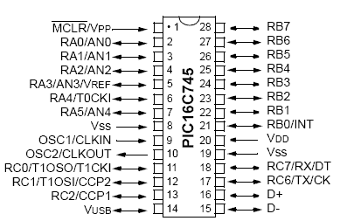
Figure 2.1 shows Pin diagram for 16C745 and figure 2.2 shows circuit diagram.

Fig 2.1 Pin diagram for 16C745

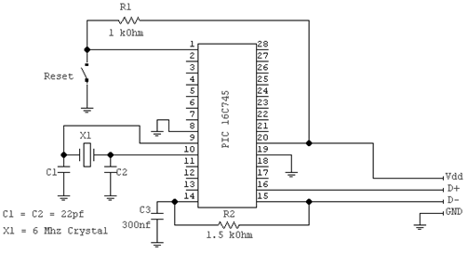

Fig 2.2 Circuit diagram

- USB cable :
USB (Universal Serial Bus) is a protocol that allows two way communications between peripheral devices and a host computer. It is hot pluggable, allowing the device to be connected and/or removed while the computer is running. A USB cable has four wires: power, ground, D+ and D-. The PIC 16C745 can only operates at low speed standard USB cable (1.5 Mbps). Figure 2.3 shows USB lines in details.
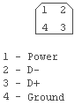
Figure 2.3 USB Lines
Where:
- Power: +5 volt.
- D- : Output serial line.
- D+: Input serial line.
- Ground: +0 volt.
Finally we list the design (Design A) advantages and disadvantages as follow:
Advantages:
- No external power needed.
- Simple software and no special OS environments is needed to run it.
- Plug ins library make the PIC programming much easier in a friendly way.
- Support the generation of random, triangle, square, sine and sawtooth signals.
- Digital Signal Processing can be implemented using simple software.
Disadvantages:
- Low speed of USB1.1 cable; about 1.5 Mbps.
- 16C745 microcontroller doesn’t support digital to analog conversion (DAC).
- Cannot work without PCs and its special software.
Section 2.2.1.2 describes design B which is based on design A, with its pros and cons.
2.2.1.2 Design B:
The main differences are listed in two points:
- Graphics LCD with keypad, so users can generate signals without any need to special software.
- External power supply (+5V) because we will not use a USB cable.
Advantages:
- Useful keypad to set the amplitude, the frequency and signal types.
- High speed more than USB1.1 (1.5 Mbps).
- Support the generation of random, triangle, square, sine and sawtooth signals.
- Can run without software or PCs.
- Expensive, about JD210.00.
Disadvantages:
- An external power supply is needed.
- Complex circuit.
- Expensive, the graphic LCD costs about 45.00 JD.

2.2.2 Pure Electronic design
In this Design we will use the following equipment listed in table 2.3.
Table 2.3 Electronic Components
Estimate Cost | Quantity | Item
25.00 JD | 1 | XR-2206 signal generator
14.00 JD | 2 | Digital PotentiometerAD5231
17.00 JD | 1 | USB Controller
As shown above, the total price after adding the price of Proton PIC environment cost will be about JD200.00.
Now, we describe some important electronics components specification.

2.2.2.1 XR-2206 Signal generator
It can be used in many applications rather than signal generation, if we use this design we may add more features to our project, the features that XR-2206 supports are:
  - Wave Generation.
  - Sweep Generation.
  - AM/FM Generation.
  - V/F Conversion.
  - FSK Generation.
  - Phase Looked Loop (VCO).
Figure 2.4 shows XR-2206 pin diagram.
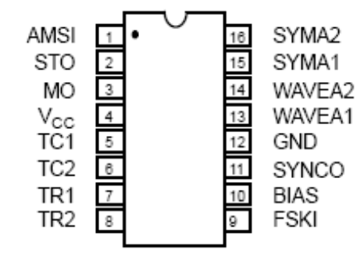

Figure 2.4 XR-2206 pin diagram
2.2.2.2 USB cable
See section 2.2.1.1 design A for more details.
Finally we conclude the advantages and disadvantages of the design.
Digital potentiometer
To control
The amplitude.
Digital potentiometer
To control
The frequency.

Advantages:

- Various pure types of signals can be generated: triangle, square, sine and sawtooth.
- Wide signals frequency range: 0.01 Hz up to 1 MHz.
- Signal modulations.
Disadvantages:
- Expensive, about JD200.00.
- Complex circuitry: we need extra electronic components like potentiometer.

2.2.3 Sound Card
In this design, we use the built-in/out sound card to generate signals from a computer.
In reality, it’s a good design to be implemented because most of computers in the world are equipped with a sound card with two common ports: Mice-In and speaker-out. So the use of these two ports to input a signal from an external oscillator and output desired signals is seen to be a good idea.
However, sound cards vary from manufacture to another in its hardware specifications like: sampling rate, maximum input voltage. But they are common in other important features like: Analog-to-digital and digital-to-analog converters.
We wrote a simple C# code along with some DLL libraries using Microsoft visual studio 2008 to generate a signal from sound card with no external circuitry. The results were as following:
- Pure sinusoid waveform with 1 volt (P-P) and a maximum frequency calculated as follows:

Max frequency (f_{max}) = sound card sampling rate / 2. [2.1]

- Pure cosine waveform with 1 volt (P-P) and a maximum frequency calculated in equation 2.1.
- Distorted triangle waveform because of noise coming from the sound card itself.
- Distorted square waveform because of noises.
- Distorted sawtooth waveform because of noises.
The distortion of generated signals except the sine and cosine one is due to the following fact that most of manufactured sound cards are designed not to pass or generate DC-components which was the main difficulty faced this design.
But what is the DC-component for a signal?
2.2.3.1 DC component
Every periodic signal contains a DC and AC component, the function of the DC component is to bias that signals. We can calculate the DC component in periodic signals by the following equation:
DC (component) = ((max) Values + (min) Value)/2. [2.2]
For example: If we have a signal extends between 0 - 5 volt, then the DC component is equal to ((0+5) / 2 = 2.5 volt) which is the average value of the signal.
Figures 2.5 and 2.6 show an example of how sound cards block DC-components and how the original signal will be extremely different.
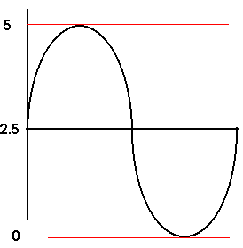

Figure 2.5 Original sine signal
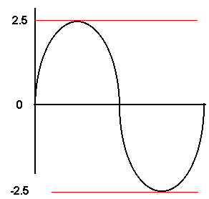

Figure 2.6 Sine signal without DC-component

As a part of our design, we found a difficult solution for this problem, but unfortunately it’s impossible for the built-in sound card as in laptops. Figure 2.7 describes the difficulty of the proposed solution.

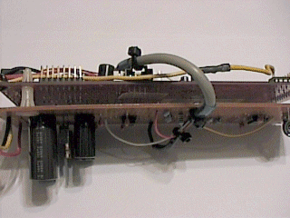
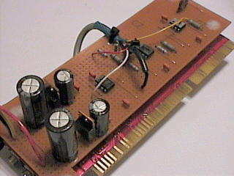

Figure 2.7a Sound card cross view Figure 2.7b Sound card top view
Finally we conclude the advantages disadvantages of the design.
Advantages:
- No external circuitry needed to generate signals.
- Simple software.
- Inexpensive.
- Easy to implement.
Disadvantages:
- High noisy output signals except sine and cosine waveforms.
- Low peak-to-peak output voltage.
- External circuitry is needed to amplify output signals.
- Output frequency varies from computer to another because it depends on the sound card specifications.
- DC-component blocking with a hard solution.

2.3 Suggested design comparisons
In this section we present a table that provides the reader with conclusion of all previous designs. As we noticed, some designs share the same features, while other do not.
Some have a lot of limitation due to their high costs, some due to the complexity of circuitry, and some have advantages that overcome their limitation.
Table 2.4 summarizes all previous designs briefly and compares each design with others.
Design Number | Main cons | Main pros | Circuit complexity | Cost estimation | Applicability
1 A | Built-in power, easy to implement. | Expensive | Not complex | JD 165.00 | Yes
1 B | Easy to implement, embedded system. | Expensive | Complex | JD 210.00 | Yes
2 | Wide frequency range. | Expensive | Complex | JD 196.00 | Yes
3 | Easy to implement, cost nothing. | DC-Component | Complex | JD 00.00 | Yes
Table 2.4 Designs comparisons

2.4 Summary
In this chapter, we gave a basic overview of projects designs.
Then we described several designs and discussed their advantages and disadvantages.
Three designs were presented to the reader and comparisons between them were presented.

CHAPTER 3
PIC MICROCONTROLLER
In this chapter, fundamental concepts of different microcontrollers are presented to provide the reader with the fundamental knowledge necessary to understand why to use PIC MCUs.
Section 3.2 presents and discusses some important reasons described why to use microcontrollers and the key elements needed to construct a PIC circuit. Circuit layout and construction are discussed in section 3.3, and then it is followed by developing a project using PIC MCU.
Section 3.4 describes in depth the PIC 16F877A MCU. Section 3.5 presents a simple procedure to create your own PIC program. Finally, section 3.6 presents the main microcontroller functions used in this project.

  - What is a microcontroller

A microcontroller is a relatively low cost single chip microcomputer. A single-chip microcomputer indicates that the complete microcomputer system lies within the confines of the integrated circuit chip.
Microcontrollers are capable to store and run the program that was written, compiled and downloaded onto it.
The main parts of a microcontroller generally consist of the Central Processing Unit (CPU), Random Access Memory (RAM), Read Only Memory (ROM), input/output lines (I/O lines), serial and parallel ports, timers and other peripherals such as an analog to digital (A/D) converter and a digital to analog (D/A) converter. Figure 3.1 shows a microcontroller.
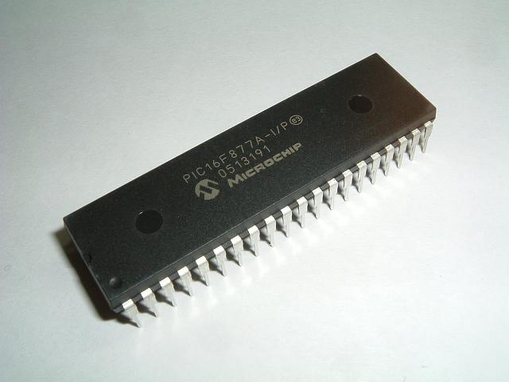
Figure 3.1 PIC 16F877A Microcontroller
  - Why to Use a Microcontroller

Microcontrollers are inexpensive microcomputers. The microcontroller's ability to store and run unique programs makes it fairly flexible.
For example, one can program a microcontroller to perform functions based on predetermined situations (1/O-line logic) and selections.
The microcontroller's capability to carry out mathematical and logic functions allows it to emulate complicated logic and electronic circuits.
The pin-out diagram of the PIC16F877A chip, which is utilized in the present work, is shown in figure 3.2.

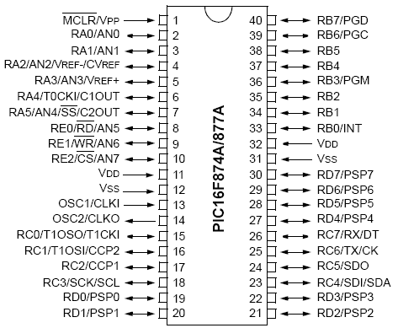
Figure 3.2: PIC16F877A Pin-out

In order to deploy a PIC16F877A microcontroller within the framework of a project, it is important to take into account the following components:
- Power supply.
- Reset button.
- Oscillator (crystal frequency).

Brief descriptions of these components are presented.

3.2.1 Power Supply

The PIC microprocessor offers a wide operating voltage range varying from 2V DC to 6V DC depending naturally on the particular device used. A simple 5V DC power supply will be used.
A 5V DC supply is easy to construct due to the availability of monolithic voltage regulators such as the 7805 positive 5V regulator, which provides good regulation as well as automatic thermal shutdown and short circuit overload protection.
The hardware configuration of the 5V DC power supply is shown in figure 3.3.
The circuit consists of a 7805 IC voltage regulator and some ripple-reducing smoothing capacitors.
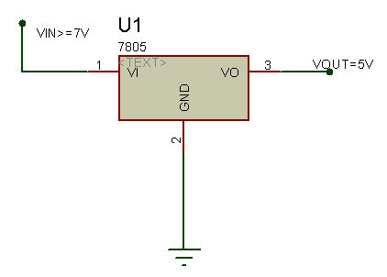
Figure 3.3: 7805 5V regulator

3.2.2 Reset button and Oscillator:

Figure 3.4 shows the connections of the reset button and crystal oscillator to the microcontroller pins (VDD, MCCLR/VPP/THV, OSC1/CLKIN and OSC2/CLKOUT).
The reset button provides additional protection to the system.
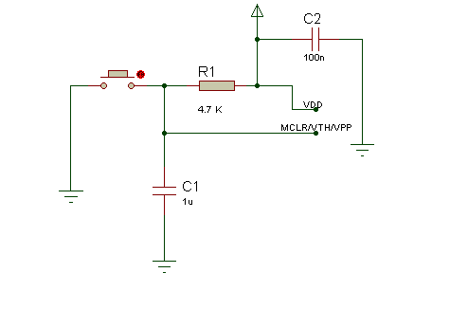
Figure 3.4a: RESET connections
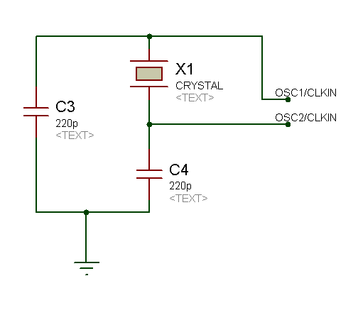
Figure 3.4b: Oscillator connections

  - Circuit Layout and Construction

It is advisable to pay some attention when constructing a microcontroller circuit to prevent frustrating circuit problems to be occurred.
With low frequency circuits in the kHz ranges, the layout is not critical as the effect of circuit board and parasitic capacitances and inductances is negligible.
At higher frequencies; in the region of tens of MHz, those effects become more pronounced, so that bad wiring can actually prevent a circuit from working.
These are some general rules that have to be considered when constructing PIC circuits:
- The oscillator crystal and capacitors should be located in close proximity to the IC with short copper tracks or connecting leads.
- A small decoupling capacitor (≈ 0.1µF) should be placed across the power supply and as close as possible to the PIC MCU.
- All circuits should be grounded to the circuit chassis at one point only. Multiple ground points can cause problems due to the nonzero resistance of the ground plane.
- All pins that act as inputs must be connected either to the positive supply rail or to ground. Inputs that are left floating can cause unnecessarily high current consumption and spurious triggering of CMOS circuits.

  - Developing a Project Using PIC MCU

Developing a PIC-based project takes only six easy steps:
- Type in the program.
- Compile the program into a binary file.
- Simulate the program and debug it.
- Load the binary program into the PIC’s memory.
- Wire up the circuit.
- Switch on and test.

  - PIC16F877A Microcontroller

At the beginning, the microcontroller, which was selected in the project, is from Microchip Technology Incorporated (http://www.microchip.com).
This was done following a thorough search and a comparison with other microcontroller candidates that have been used in this project.
Some of reasons and key features for choosing the PIC16F877A are listed in table 3.1 and discussed as the following:
- 8K x 14 words of FLASH Program Memory; this is quite enough for this project.
- Only 35 single word instructions to learn with Assembly. Therefore, it is not so hard to master.
- Interrupts capability.
- Low cost (around $10).

Key Features | PIC16F873 | PIC16F874 | PIC16F876 | PIC16F877
Operating Frequency | DC - 20 MHz | DC - 20 MHz | DC - 20 MHz | DC - 20 MHz
FLASH Program Memory (14-bit words) | 4K | 4K | 8K | 8K
Data Memory (bytes) | 192 | 192 | 368 | 368
Interrupts | 13 | 14 | 13 | 14
I/O Ports | Ports A,B,C | Ports A,B,C,D,E | Ports A,B,C | Ports A,B,C,D,E
Serial Comm. | MSSP, USART | MSSP, USART | MSSP, USART | MSSP, USART

Table 3.1 Key Features of Different Microcontrollers

  - Construction of PIC Programs

The exact structure of a PIC program highly depends on the programmer’s personal programming style. It is advisable to put comments into programs to indicate the purpose and operation of the code and to facilitate maintenance at later stages.
A program is made up of the following four elements in a file as following:
- Comments.
- Pre-Processor Directives.
- Data Definitions.
- Function Definitions.

A compiler requires an “include” of the devices and libraries attached to the microcontroller, including the microcontroller itself for sure within the code, such as:
#include <16f877a.h>
Where “16f877a.h” library includes all the features and program characteristics for the microcontroller, such as the available ports, memory size, operation frequency, etc.

  - Microcontroller Main Functions

The basic function of PIC 16F877A/P MCU in our project is to provide the path for directing binary stream from a PC to the circuit and vice versa in order to guarantee delivery of binary data from the circuit to the PC over the parallel port, and to synchronize the input data stream from an external device with the circuit to prevent overwhelming the PC since different PCs run at different frequency, but with a fixed PIC frequency.
  - Summary

In this chapter, an overview of microcontrollers was given and the basic characteristics were presented.
We described several key features and uses of microcontrollers.
Then we introduced the basic hardware components needed to construct a PIC circuit.
Finally the main microcontroller functions were provided at the end of this chapter.

CHAPTER 4
HARDWARE DESIGN

In this chapter, Section 4.1 presents hardware components Specification in details.
Section 4.2 discusses the digital-to-analog converter (DAC) construction.
Parallel port interfacing is discussed in section 4.3.
An overall hardware circuitry is presented in section 4.4.

4.1 Hardware components specifications

4.1.1 16F877A PIC microcontroller

Figure 4.1 shows 16F877A pin-out connections.

Figure 4.1: 16F877A pin-out connections

Table 4.1 describes each PIC 16F877A port and its pins used in our project in details, other ports or pins that are not described are never used in the project.

Pin(s) name | Description
PIN 1 | (MCLR/Vpp) is connected to the 5V power supply. When this pin is connected to ground, the microcontroller will be cleared and begin execute the program from start (RESET).
PIN 11, PIN 32 | (VDD) is connected to 5V power supply.
PIN 12, PIN 31 | (Vss) is connected to ground.
PIN 13, PIN 14 | (OSCI1, OSCI2) are connected to a 20MHz crystal frequency to operate the PIC.
PORT A | RA0 used as analog to digital converter, the input analog signal must be connected to this pin to use the circuit as an oscilloscope, as will be explained in later sections. Any change will cause the PIC program to jump to its related ISR.
PORT B | Used for interrupt. Any change in this port will cause the PIC program to jump to a pre-defined Interrupt Service Routine (ISR) as will be explained in later sections.
PORT C | RC0 - RC7 are connected to resistors network (Digital to analog converter) to generate the required signal.
PORT D | RD0 - RD7 are connected to the data bus in the parallel port to exchange data between a PC and the circuit.
Table 4.1: PIC16F877A functions

4.1.2 Crystal frequency and its configuration
The crystal oscillator generates the clock pulses needed for the operation of the microcontroller. The PIC16F877A can operate at a frequency of 20MHz, so a suitable crystal oscillator is one with about 20MHz.
4.1.3 Power supply
Power is available from an external power supply. Devices may either be self-powered or bus powered. Self-powered devices draw power from an external source.
Most devices that connect to PCs via Universal Serial Bus (USB) take power from the USB (100mA, 5V). But since we use the parallel port to interface our circuit, we have to request help from an external power adapter.
The following describe the key features of the adapter:
- Positive/Negative Voltage supply (12 / -12 V).
- Maximum current of 500mA.
Figure 4.2 shows power adapter similar to what we used.
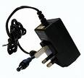

Figure 4.2: Power supply adapter

4.1.4 Other components
There are other essential connections that ensure proper, better and safer operation for the unit.
Here are some examples:
- A resistors network responsible for converting the digital byte stream coming from the PIC into an analog form.
This network will be discussed in depth in the next section.
- Parallel Port to interface the circuit with a PC.
More discussion will be made in later sections.
- A master reset button.
- A low capacitance (~10uF) to smooth currents and prevent spikes.
- Some LEDs indicate that circuit is working probably.
- Some smoothing capacitor to smooth the current drawn by the power adapter and to limit the current and prevent spikes.
- A power plug to draw the current from the power supply.

4.2 Digital-to-Analog Converter (DAC) construction

An alternative to the binary (x-Bit) digital to analog converter ICs is to construct our own DAC converter. Most of DAC ICs require many external powers to make it enabled to convert. And this will complicate the circuitry and increase the cost. However, using such ICs is more secure for professional, pure and smoothed output.

What about the cost?
We used the idea of the R/2R ladder to convert the digital byte stream coming from the PIC to the analog form, but with little circuitry. We removed the op-Amp IC at the output and connected a short circuit instead of the op-Amp. This is not a standard DAC convert but its working well. Figure 4.3 shows the DAC circuitry and then we describe some basic equations.

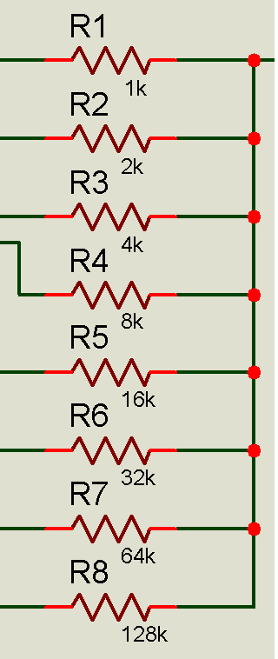
Analog output
8-bit data

Figure 4.3: Resistor network DAC converter

Analyzing this resistor network mathematically is a bit complex. However we analyze it by applying different digital inputs and measure the output at each stage, we noticed that the relation between the digital input and the output is approximately linear.
Table 4.2 concludes the result we obtained and figure 4.4 shows the linear relation between the input and the output.

Digital binary input | Equivalent decimal input | Analog output  (Volt)
00000000 | 0.0 | 0.000
00011001 | 25.0 | 0.475
00110010 | 50.0 | 0.950
01100100 | 100.0 | 1.900
10000000 | 128.0 | 2.432
11001000 | 200.0 | 3.800
11111111 | 255.0 | 4.845

Table 4.2 Digital input and analog output relation

Math which describes this process is very simple, an 8 bit converter will divide the 5 volts into 255 steps, each step has a value of 5/255 = 0.019 V.
Then the output voltage for the converter should be equal to the binary input multiplied by the step value, e.g. for an input of 129 (1000 0001 in binary) the output voltage should be: 129 X 0.019 = 2.451V.
An alternative mathematics method to calculate the output voltage is given in equation 4.1:

V_{out} = (D0/255 + D1/128 + D2/64 + D3/32 + D4/16 + D5/8 + D6/4 + D7/2)*5 [4.1]

However, the above equation describes the output theoretically not practically.
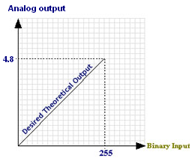

Figure 4.4 Digital input / analog output relation

The digital data enter through the 8 lines (D0 to D7) are going to be converted to an equivalent analog voltage (Vout) by the mean of the R/2R resistor network.
Actually a lot of commercial Digital to Analog converter ICs is based on this same principle.
This network is built using resistors with a value of 2^{n-1} where n is the bit position in the range of (1-8).

Resistor value = 2^{n;} n = [0-7] [4.2]

Applying the above equation will set the resistors values to 1K, 2K, 4K, 8K, 16K, 32K, 64K, 128K ohm.

  - Parallel port interfacing

    - What is a parallel port?

A parallel port is a type of interface found in computers to connect various peripherals. It is also known as a printer port or Centronics port. The IEEE 1284 standard defines the bi-directional version of the port. Figure 4.5 shows the parallel port cable that we used in this project.

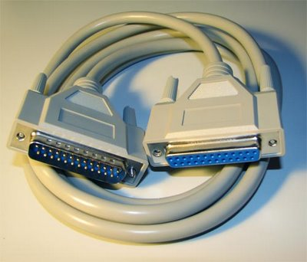

Figure 4.5: Parallel port cable

    - Parallel port Registers and BIOS mode

Traditionally IBM PC systems have allocated their first three parallel ports registers according to the configuration in the table 4.3 below.

Port name | Starting I/O (HEX) | Ending I/O (HEX)
LPT 1 | 0x378 | 0x37F
LPT 2 | 0x278 | 0x27F
LPT 3 | 0x3BC | 0x3BF
Table 4.3: Parallel port registers

Newer Parallel Ports are standardized under the IEEE 1284 standard was first released in 1994. This standard defines 5 modes of operation as follows:

- Compatibility Mode.
- Nibble Mode.
- Byte Mode.
- EPP Mode (Enhanced Parallel Port).
- ECP Mode (Extended Capabilities Mode).

We decided to choose the ECP mode to enable the bi-directional exchange of data between the circuit and PC. Next we will mention how to set the operation mode to ECP in the BIOS (Basic Input Output Settings):

- Restart you PC.
- Press the delete key at the startup.
- Go to “Integrated Peripheral Devices”.
- Open the “Parallel Port Configurations”.
- Set the mode to ECP or EPP + ECP.

It’s recommended to set the mode of parallel port to EPP or ECP+EPP to enable the circuit to send/receive data byte. Ignoring this step will cause many problems and the circuit will not work probably. The need of this operation mode will be clearly understood later on.
Table 4.4 demonstrates the pin’s usage in the circuit and the PC.

Pin no  (DB-25 type) | ECP signal | Direction in/out | Register | Hardware inverted
2 | D0 | In /out | Data | No
3 | D1 | In /out | Data | No
4 | D2 | In /out | Data | No
5 | D3 | In /out | Data | No
6 | D4 | In /out | Data | No
7 | D5 | In /out | Data | No
8 | D6 | In /out | Data | No
9 | D7 | In /out | Data | No
1 | C0 | In /out | Control | Yes
14 | C1 | In /out | Control | Yes
16 | C2 | In /out | Control | No
17 | C3 | In /out | Control | Yes
Table 4.4: Parallel port pin’s uses

4.3.3 More analysis:

  - Data bus (D0 - D7) is used to carry a byte stream.

    - In the oscilloscope: it is used to carry the digital converted byte from an external analog signal. The PIC program reads input analog signal from A0 (PORT-A in PIC16F877A, see table 4.1) and then outputs the result to the data bus in the parallel port.
    - In the oscillator: It is used to send the type of signal to be generated, its amplitude and its frequency from PC to PIC.

  - Control bus (C0-C3): It is clearly used to input an analog signal and load it to the PC over the data bus (Oscilloscope).
Since different CPUs vary in speeds, RAM, etc., we need a certain method to maintain synchronization between PC and PIC (which operates at fixed frequency (~20MHz).
The optimal solution was to use some extra bits in control registers to solve the problem. A step-by-step scenario will be discussed in chapter 5.

  - To access parallel port registers, we should use some APIs and know the register’s addresses. Control register has a 0x37A address while data register has a 0x378 address.

  - Overall hardware circuitry

After discussion of main hardware components and specifying their needs and settings in our project, we present the overall circuitry and basic block diagram.
However chapter 5 describes how the software manages and controls the operation of the circuit clearly.
Figure 4.6 shows the overall circuit while figure 4.7 shows the basic block diagram.

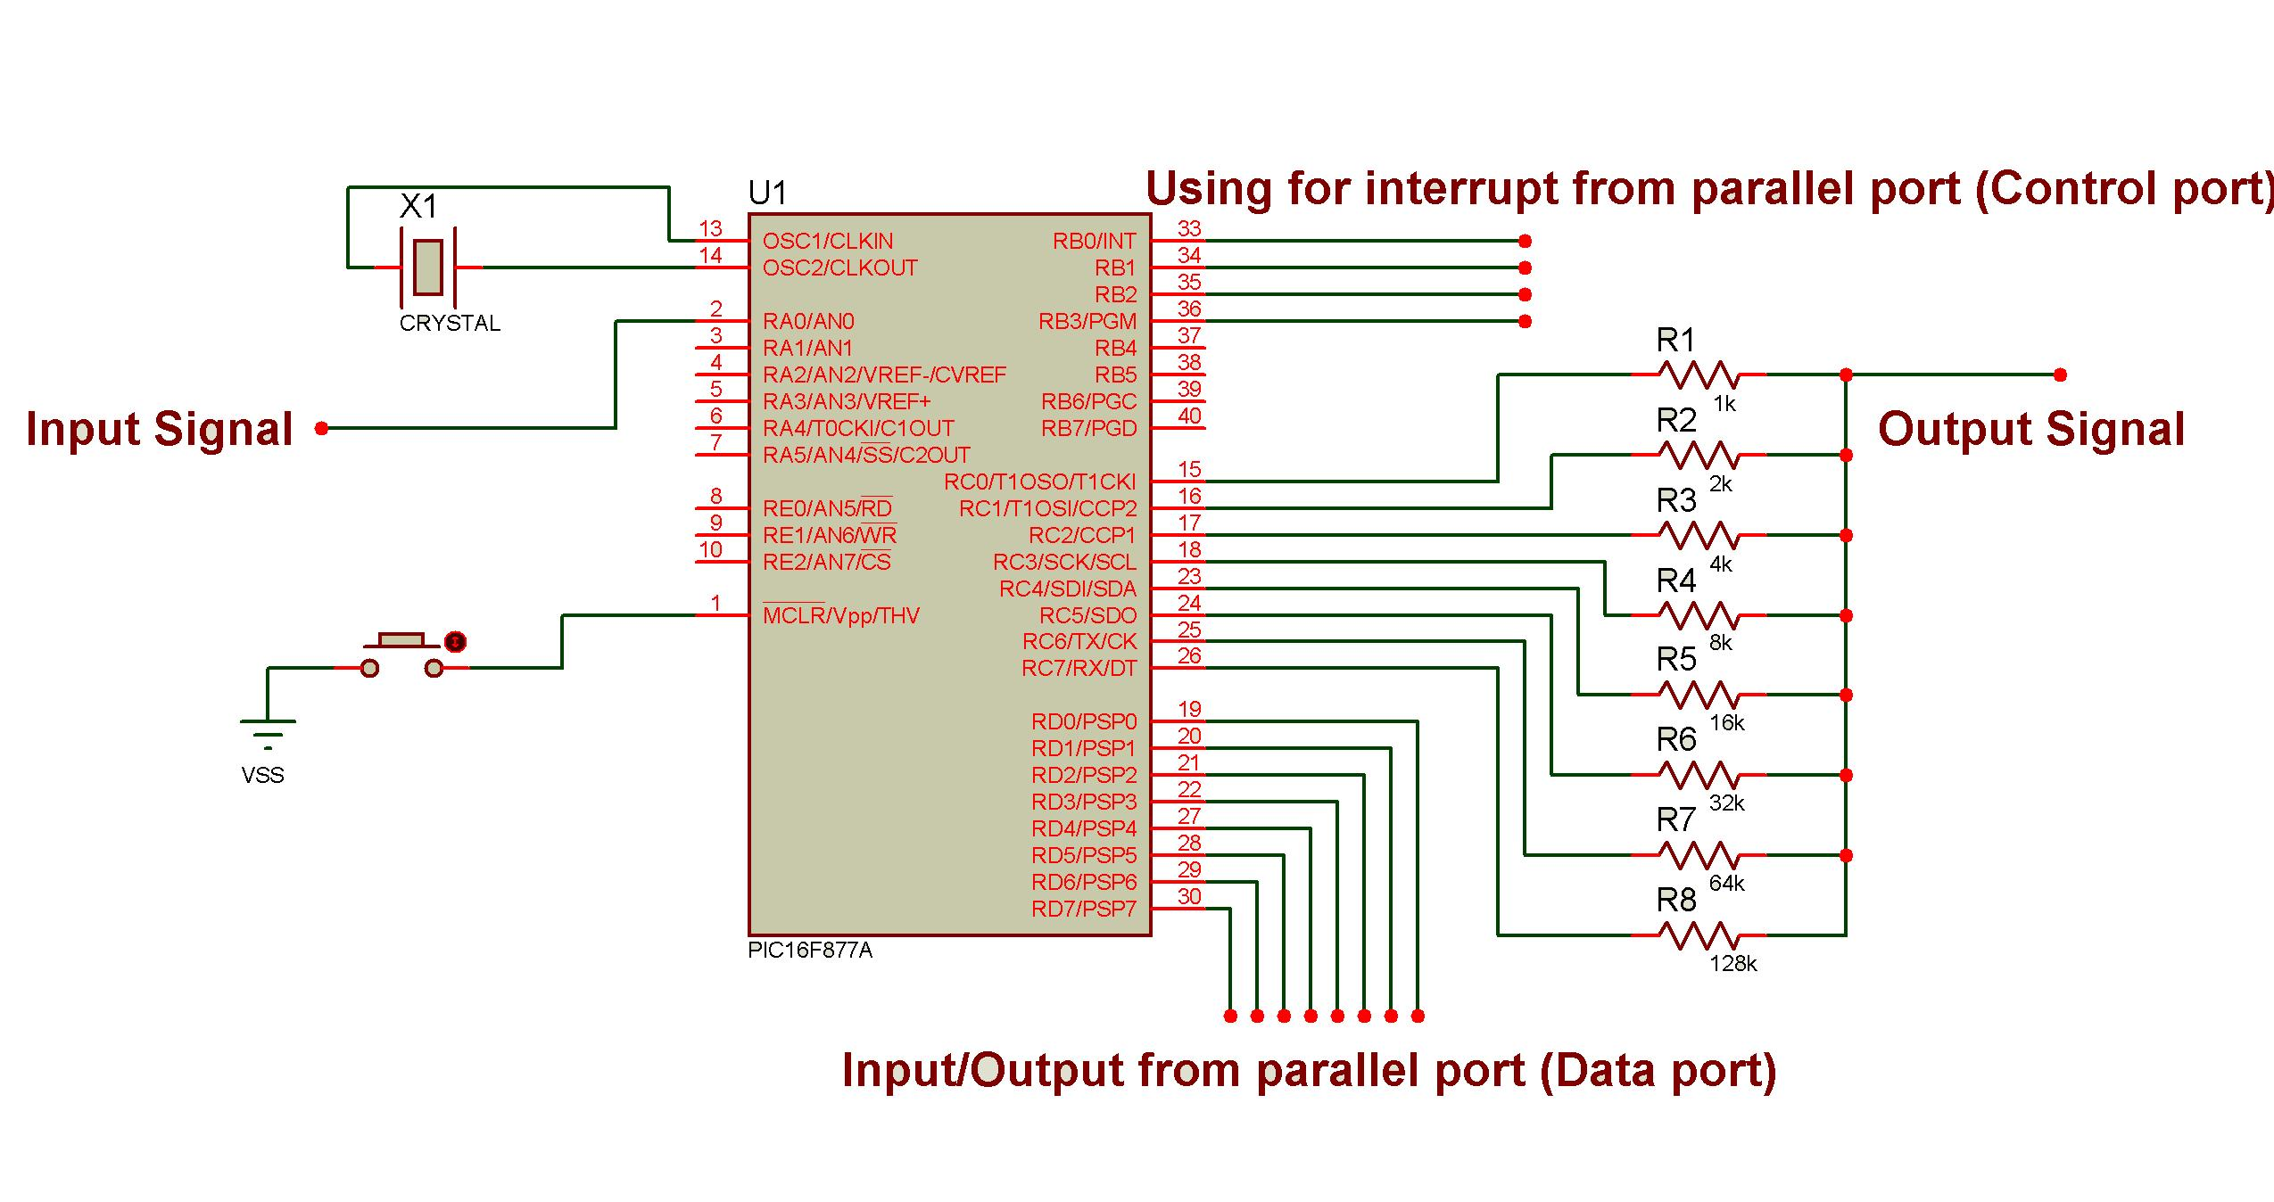
Figure 4.6: Overall circuit

  - Summary

In this chapter, we gave a deep overview of hardware projects design.
Then we described hardware components and discuss their key specifications.
DAC converter is presented in a hardware view and well described mathematically.
A deep overview of parallel port and use of their registers were introduced.
An overall hardware circuitry is presented at the end of chapter.

CHAPTER 5
SOFTWARE DESIGN
In this chapter, the required software is discussed in section 5.1.
Other software programming tools are presented in section 5.2.
A basic software model is presented in section 5.3.
A step-by-step scenario is discussed in section 5.4 to show how software integrates with the hardware circuitry and the oscilloscope synchronization problem is also discussed.
Section 5.5 presents how to achieve synchronization between the PC and the PIC.
A discussion of GUI application is presented in section 5.6.
Some important mathematics equations are discussed in section 5.7.
We present a conclusion in section 5.8, followed by a future work in section 5.9.
At the end, the summary of this chapter is given in section 5.10.

5.1 Required Software

The programming needed for the project is divided into four main parts:
- Programming micro-program that monitors and undertakes the operation of the microcontroller.
- Programming GUI (Graphical User Interface) application under .NET framework environment.
- Developing a Dynamic Linked Library (DLL files) that handles responsibility to interface the GUI with the parallel port registers.
- Developing User Account Controls (UC) and other associated DLL files to generalize the application to be used under .NET framework environment.
- Developing a deployed project (Setup.exe) to enable all users to install the project in their own operating system environment.
The micro-program will be loaded into program memory of the controller. It is written using either the Assembly language of the PIC16F family, or using the C language.
The GUI application will be installed on the operating system. This application is used to communicate users with the hardware.
The parallel port library is needed to send/receive information between the PIC and the PC. And the User Controls (UC) is optionally needed to enable other user to drag and drop these controls like any other built-in controls in .NET framework environment.
The deployment project is optional, but sometimes it is needed when there are no .NET framework environment installed in user OS (Section 5.2 will discuss other important perquisites).

  - Software programming tools

This section describes the software programming tools needed to develop the required software mentioned in section 5.1. Table 5.1 summarizes these tools.

Software name | Description
Microsoft Visual Studio.net 2008 | The main development environment.  We used the latest version from Microsoft products to build our GUI project using C#.net 3.5.
PIC C Compiler v 3.249 | To program the PIC16F877A using C language not assembly.  This program provides programmers with huge built-in functions needed to program most of PIC families.
Protues v7.0 | Used to test, debug and draw all needed circuits.
Table 5.1: Software programming tools

  - Basic software model


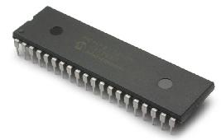
Client PC
GUI application
Runs at
Parallel port interfacing DLL
User Account DLL files and class libraries
Run in
PIC software
Oscilloscope and Oscillator ISRs
Needed Header files
Included in

Data Exchange model (send/receive information)

Figure 5.1: Basic software model

  - Step-by-step software scenario
The flowchart appeared in figure 5.2 describes the real-time operation and how PIC micro-program and the GUI software communicate with each other over the interfacing circuit.
Also it describes most of possible user inputs. This is followed by some description for both oscilloscope and oscillator operations.

Oscilloscope
Else

RESET

Start
Select signal type (Sine, Triangle, Square, Sawtooth)

Input signal amplitude
Input signal frequency
Users choose oscilloscope or oscillator
Input analog signal from PORT-A (A0) automatically
Yes
No
Yes
Generate the signal

Figure 5.2: Software flowchart

    - Oscilloscope and synchronization problem
Some common details related to this topic are recommended to be understood (Reviewed from chapter 4):
- Data bus register (Parallel port) is connected to the PIC on Port D.
- The DAC converter (Resistors network) is connected on port C.
- Analog input signal is connected on port A, pin A1.
- Control bus (parallel port) is connected on port B.

- The PIC enters in a wait state to decide whether to enter the oscilloscope or oscillator mode.
- The user chooses the oscilloscope option in the GUI program running on PC. The program will automatically send a decimal value equal to one (00000001 in binary) over the data bus (address: 0x378 H).
- The PIC receives the transmitted byte, checks it and makes a decision to enter the oscilloscope state.
- The PIC will check pin A1 (located in PORT-A), if any change occurred at this pin, it will convert the input analog signal to its equivalent digital byte presented by a decimal value in the range of (0-255). The PIC at this stage will use a built-in function to do the job. (READ_ADC()).
- The PIC then sends the converted value over the parallel port (data bus).
- The PC will immediately prepare itself to read the data bus content. This is done by loading the digital byte (0x32) into the control register (address: 0x37A).
- Now the PC has got the data byte from Port-D and immediately plots it on the screen.
- Go to and repeat stage no. 3 until PC stops the operation.
From previous scenario, it is clear that PC controls the operation with help of PIC micro-program. This scenario is similar to the STOP-and-WAIT algorithm used in many computer fields.
As we mentioned in previous chapters, the above steps are necessary because the PIC runs at a frequency which differs from other CPUs speed, and to produce a hardware compatible application that runs at different hardware specifications.
To see the PIC micro-program C code, please refer to Appendix A, page 5.

    - Oscillator and synchronization problem
- The PIC enters in a wait state to decide whether to enter the oscilloscope or oscillator mode and enable the interrupt.
- The user chooses the oscillator option in the GUI program running at the PC. The program will automatically send a decimal value to the data bus register. This value is categorized into four types:
  - Decimal 10: Generates square waves.
  - Decimal 11: Generates sine waves.
  - Decimal 12: Generates triangle waves.
  - Decimal 13: Generates sawtooth waves.
- The PIC receives the transmitted byte on port-D, interprets it and decides to generate the required signal.
- The PIC will enter in a wait state until the user enters the signal’s amplitude.
- Upon receiving the amplitude byte, it will enter again in a wait state until it receives the second byte (frequency).
- The PIC immediately calls the suitable subroutine and start to generate the signal.
- The user may want to change the signal type, amplitude or frequency. The PIC micro-program is programmed and equipped with an intelligence interrupt service routine, it’s always check for any request to change the signal, amplitude or frequency and immediately response to the user without affecting the system’s performance or disturbing the generated signal.
This is done when PC loads a (0x15) byte into the control register to request a change.
- Go to and repeat stage no. 2.
  - PC and PIC synchronization

As described in section 5.4, the function generation depends on the interrupt on port B, data bus register on port C and control register.
The PIC micro-program is always in communication with the GUI program sends and receives information and controls bytes needed to stabilize the system and to insure the correct output. In order to achieve this, a synchronization method is used in different stages. Figure 5.3 shows a general sequence diagram of the operation.

Personal Computer (PC)
PIC program
Send the data byte (SB)
Convert to digital

Start convert

Store the byte and plot it

Loop until reset

Personal Computer (PC)
PIC program

Signal type

Set the amplitude
Set the frequency
Loop until change in (signal type, amplitude or frequency)
Start generate the signal

Send new value according the adjustment

Update the change
Return to generate the signal according the new value

Figure 5.3: General synchronization sequence diagram

The control register in the parallel port is configured to give the complement of three pins. For more details see chapter 4, table 4.4.

C4 C3 C2 C1 (Control bus in the parallel port)

B0 B1 B2 (Port B on the PIC16F877A)
If PC sends a (0x15) byte to the control register, the pin B0 will receive it as high indicating that there is a request change in signal type, amplitude or frequency and then starts functionality.
At PIC side, it will check if B0 is high and know that the user requests to change the signal type and immediately read new data from the data bus.
If the user decides to change the amplitude he/she will set the amplitude data byte into the data bus and set the control register to decimal 9. Immediately PIC will jump to the desired ISR to change the amplitude value. Another possible situation is to change the frequency; the same operations will be taken but with loading decimal 10 into the data bus.

  - Mathematics equations
- When users load the frequency data byte over the data bus, the following change is made:
  - PC side :
Sent byte = 1000 * (2 / user byte (KHz) ) / 3.6 [5.1]
  - PIC side :
Received byte = sent byte
- When users load the amplitude data byte over the data bus, the following change is made :
Sent byte = user value * 255 / 5 [5.2]
Where:
Sent byte: An 8-bit data sent and loaded to the data bus (0-255).
User value: A floating number entered by users (0-5).
- When a data byte is sent by PIC to PC through the parallel port, the following is made at the PC side:
Modified byte = received byte * 5 / 255 [5.3]
Where:
Received byte: The byte that is sent from PIC on port D.
Modified byte: the mapped byte into the range of (0-5) volt.
  - GUI applications
The Graphical User Interface (GUI) application is programmed using C#.NET under .NET framework environment 3.5 using Microsoft Visual studio 2008. The C# language is one of the most powerful languages in.NET environments. Next we mentioned some of key features why we chose this language to develop our project:
- It is on .NET, inherits the features of automatic memory management and garbage collection.
- Unsafe operations such as direct memory manipulation are not allowed.
- Equipped with a huge built-in functions, which simplify the development operation.
- Easy to learn, to use and to build a user friendly interface by drag and drop only.
- Contains professional tools to communicate with external devices.
5.7.1 Installing the GUI application
In order to run the main application, user’s machine must be equipped with Microsoft .NET framework environment 3.5, any version less than 3.5 will lead to problems and your copy of application wouldn’t work.
Also it is very important to install the Windows Installer 3.1; Most of modern Microsoft Operating Systems are equipped with this program.
To overcome these problems, we deployed our project and produced an intelligent executable file (Setup.exe) that detects the application prerequisites and capable to run on most of operating systems such as Microsoft, UNIX, LINUX, etc.
When having the installation finished successfully, an application shortcut is created automatically on the user’s desktop, and a folder is added to the user’s start menu. This application is compatible with Windows VISTA X86 and X64 versions too.
5.7.2 Using the application
The application is developed using the Multi Document Interface (MDI) technology to enable user to navigate quickly between the oscilloscope and oscillator windows. Also it is very simple to be used by all users, not only by engineering students.
Figure 5.4 shows the main oscillator window.
Figure 5.4: Oscillator window
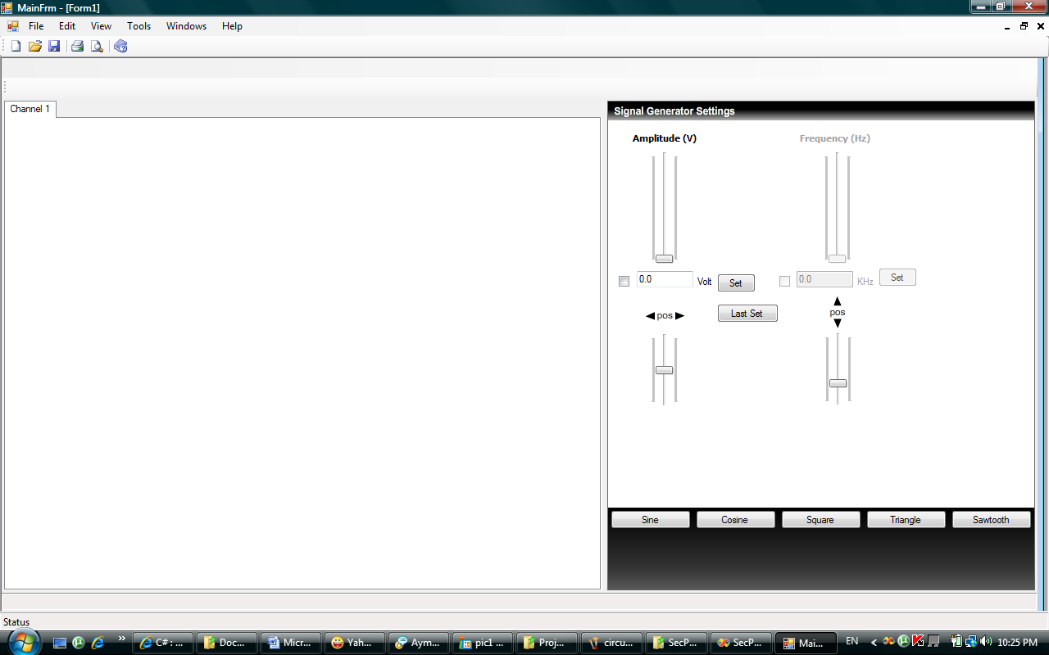
5.7.2.1 Oscillator window
The above window contains different control:
1. A track to change the amplitude.
2. A track to change the frequency.
3. Four buttons to select the type of signals.
Figure 5.5 shows a snapshot for generating a square signal with a frequency of 100 KHz and a peak-to-peak voltage equals 3.68 volt.
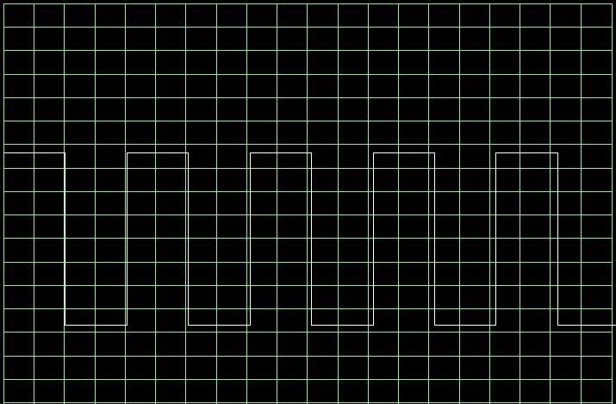
Figure 5.5: A generated square waves in oscillator window
We saw that to generate a signal, user has only to decide the type of signal and then choose the amplitude and the frequency.
The following summarize the oscillator specifications:
- Supports four types of signals: Sine, Square, Triangle and Sawtooth.
- The amplitude can be changed in the range of (0-5) p-p volt.
- The frequency varies upon the signal type. Table 5.2 summarizes the limitation of each signal.

Signal type | Max frequency | Max amplitude (P-P)
Square | 500.00 KHZ | 5 volts
Triangle | 2.00 KHZ | 2.5 volts
Sawtooth | 4.00 KHZ | 2.5 volts
Sine | 2.400 KHZ | 5 volts
Table 5.2: Different signal types specifications
Figure 5.6 shows snapshots of generated signals captured from a commercial screen.
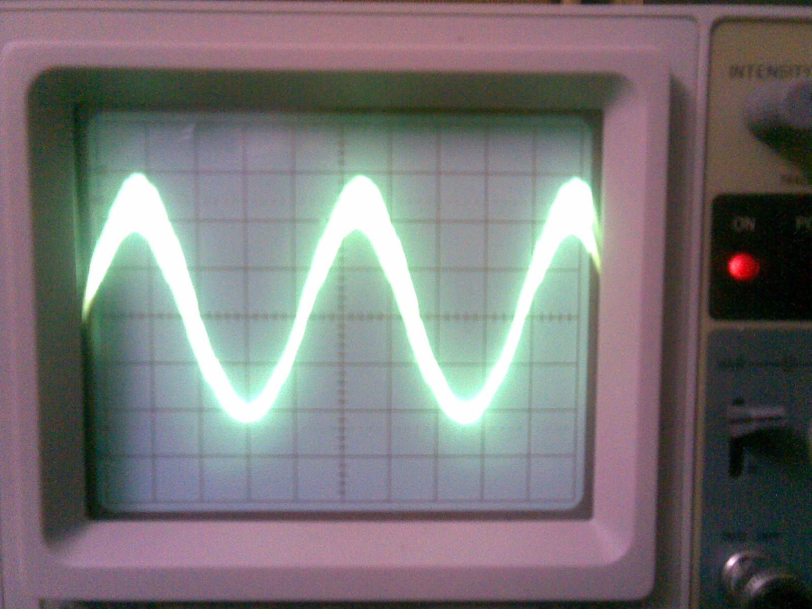

Figure 5.6a: Sine wave (2.4KHZ, 5 volt)
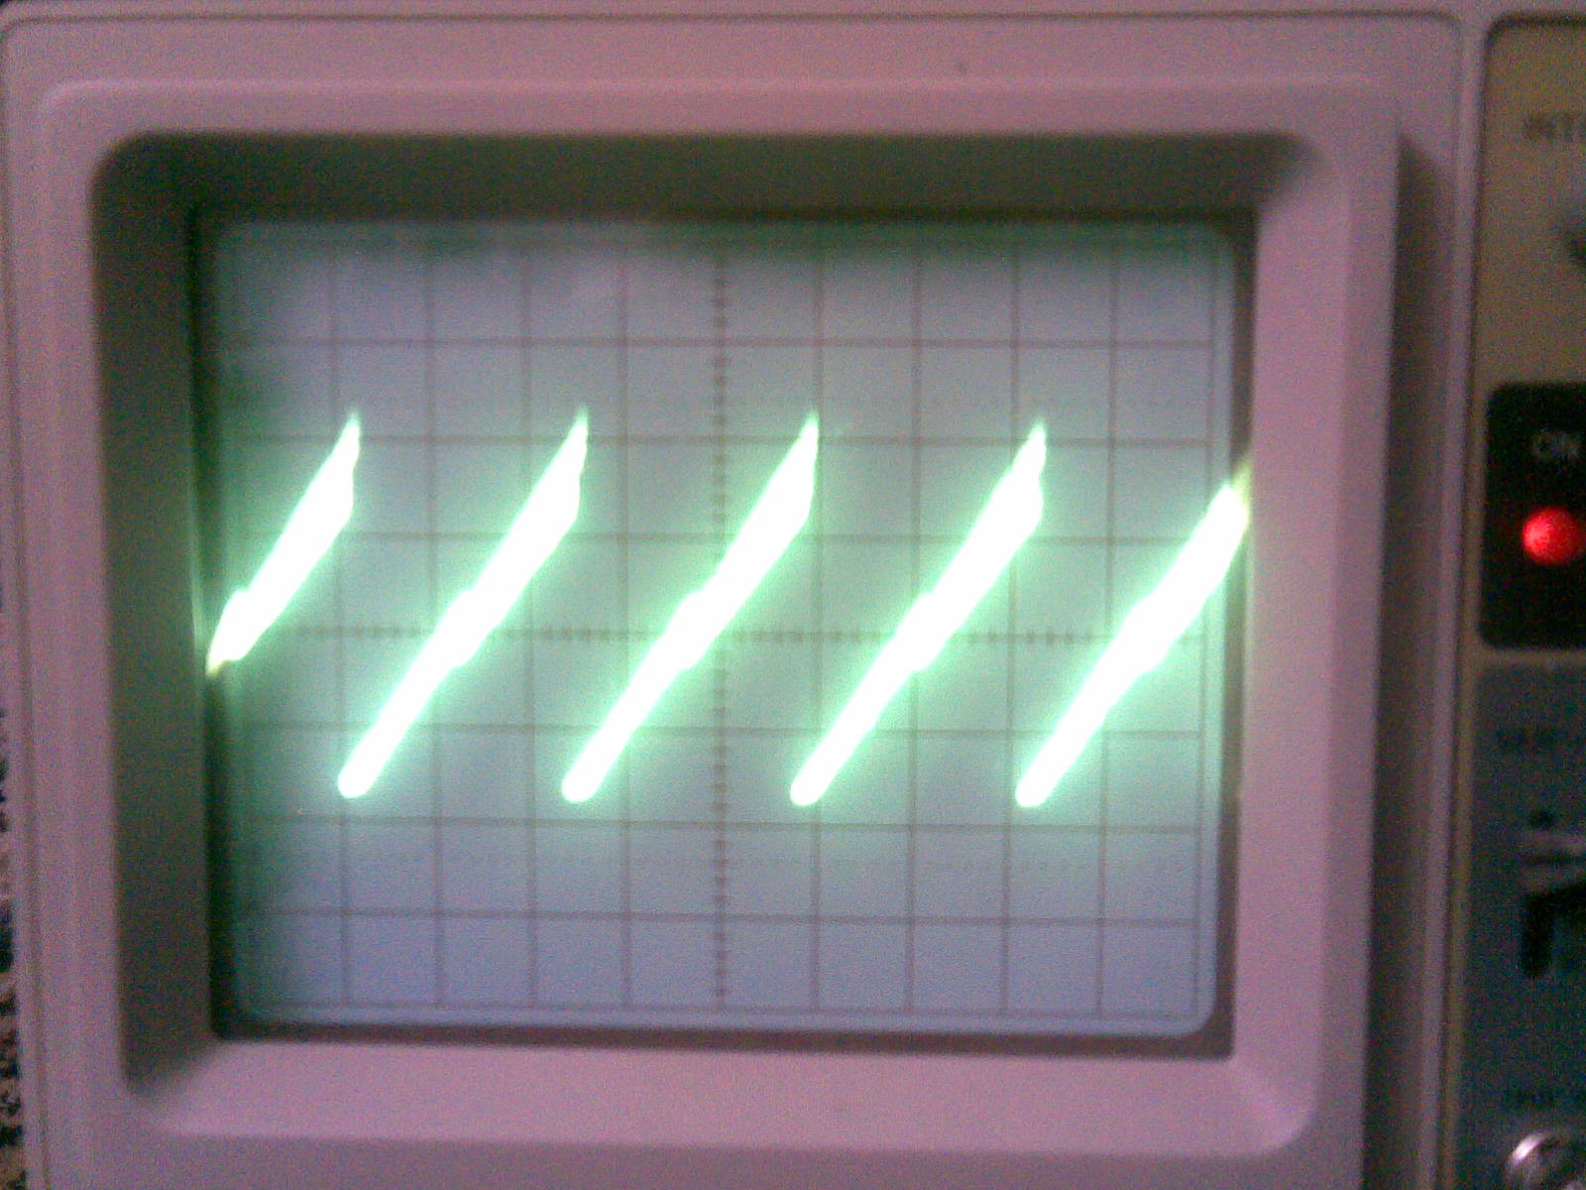

Figure 5.6b: Sawtooth wave (4 KHz, 2.5 volt)
5.7.2.2 Oscilloscope
Figure 5.7 shows the oscilloscope window.
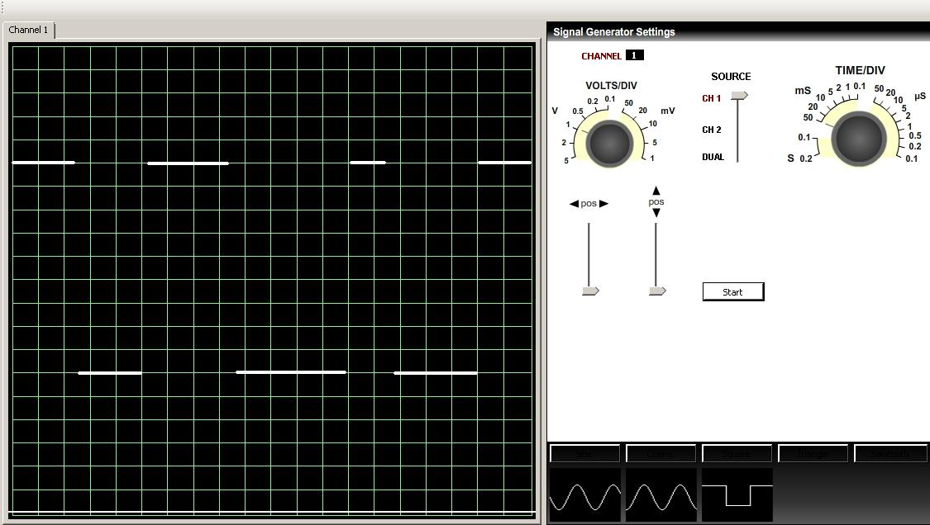

Figure 5.7: Oscilloscope window
5.7.2.3 Some important comments:
- The black screen displays the input analog signal. This is done by the synchronization between PC and PIC as discussed above. In this case the input signal from an external device was a square signal.
- Two nods are located to the left of the black screen, they are adjustable nods. Users may change voltage per division and time per division.
- Two track bars are needed too. Users may shift up or shift down the signal.
- A button is located to start synchronization with the external device. To see how the synchronization process is done, you can refer to section 5.4 in this chapter.
  - Conclusion
We could make an improvement in engineering laboratories by developing a new hardware circuitry along with a personal computer. We could build a stable project that satisfies engineering students dream to have an oscilloscope and oscillator at home.
The commercials oscilloscopes and oscillators sold in electronics stores cost extra money. Our project reduces total cost, total size and weight.
  - Future work
In this thesis, we proposed a full hardware/software project to build an important engineering device. However it might be necessary to develop the hardware circuitry to be communicated to PC via Universal Serial Bus (USB). This is necessary to speed up the system, reduce system overhead and improve performance.
Several important techniques can be taken and applied on the system to enhance its operation. We could add some extra hardware component to generate more smoothed, strong and high quality output signal. Also it will be useful to enable the system communicate with an operator without a PC. This is done by adding a graphical LCD screen and a small keypad.
  - Summary
In this chapter, we discussed in depth all software and tools needed to develop the final application. A general software model is used to describe the operation and communication between PIC and PC. Also we discussed in depth how the synchronization process is done. The min limitations of our project are explained. A simple tutorial of how to use the software is included at the end of this chapter too.

